Summary
- What is an operating system? What are the four major tasks performed by an operating system? Please explain them briefly. (10%)
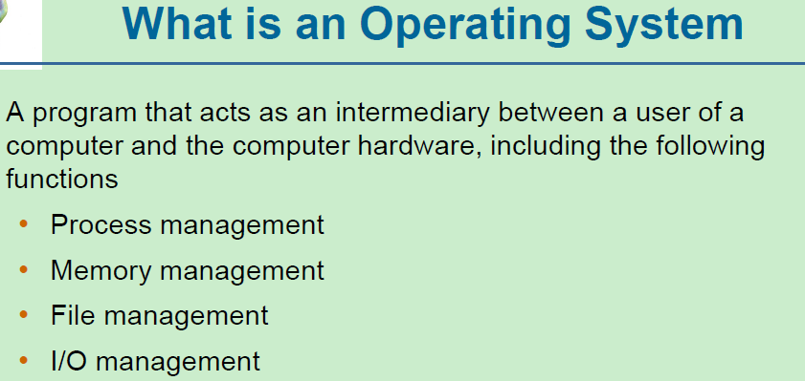
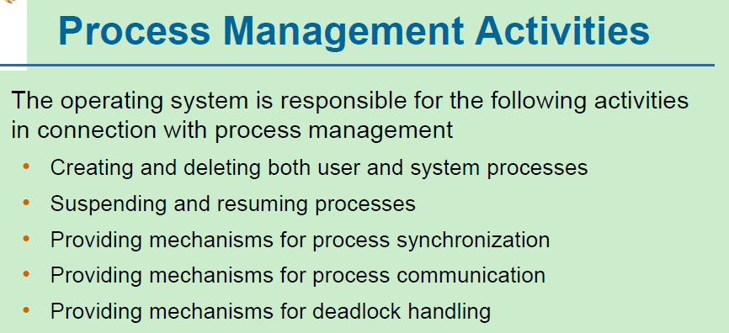
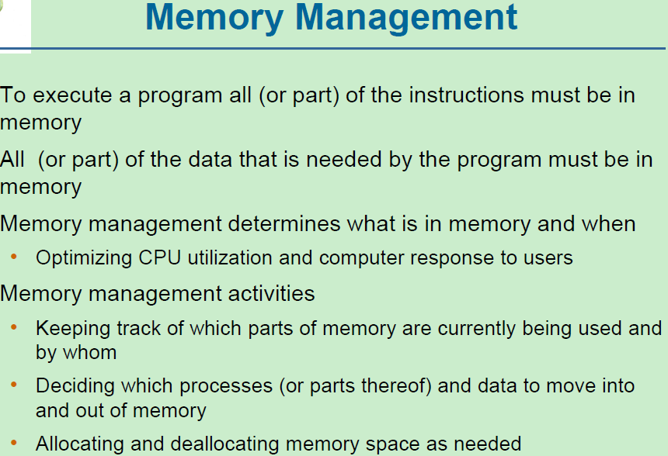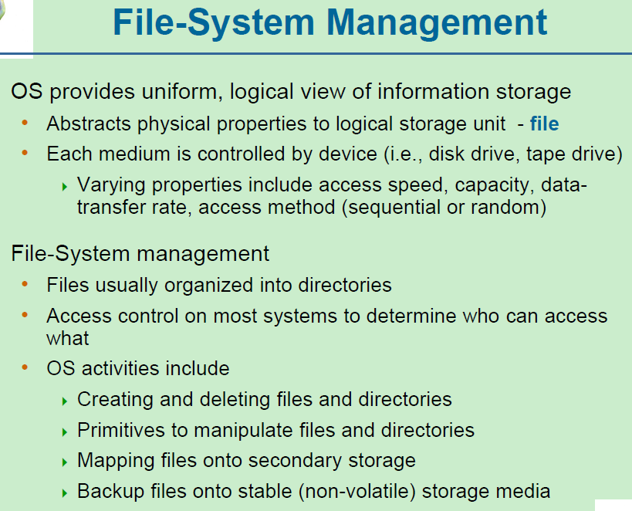
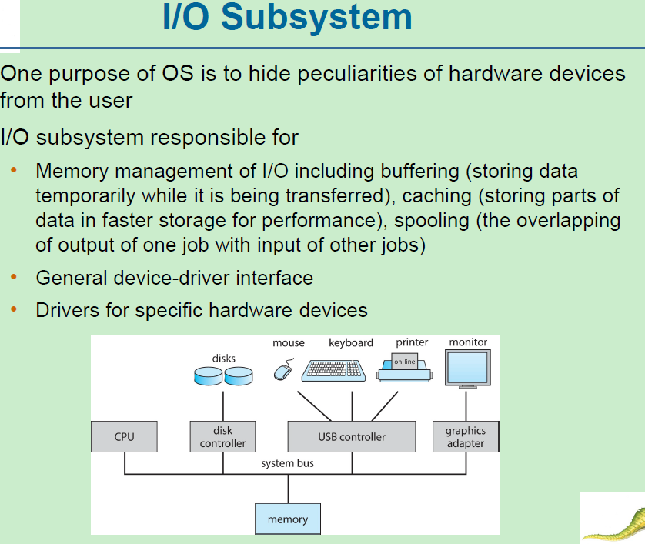
- How could a system be designed to allow a choice of operating system from which to boot? What would the bootstrap program need to do? (10%)
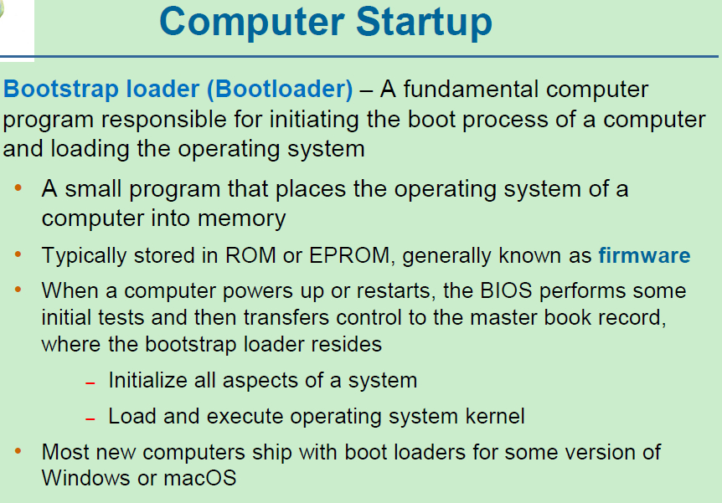
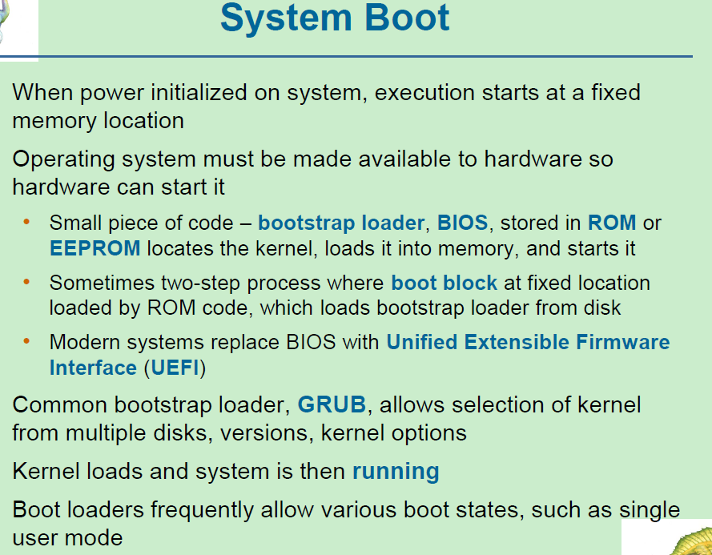
- What is the main advantage of the microkernel approach to system design? How do user programs and system services interact in a microkernel architecture? What are the disadvantages of using the microkernel approach? (10%)
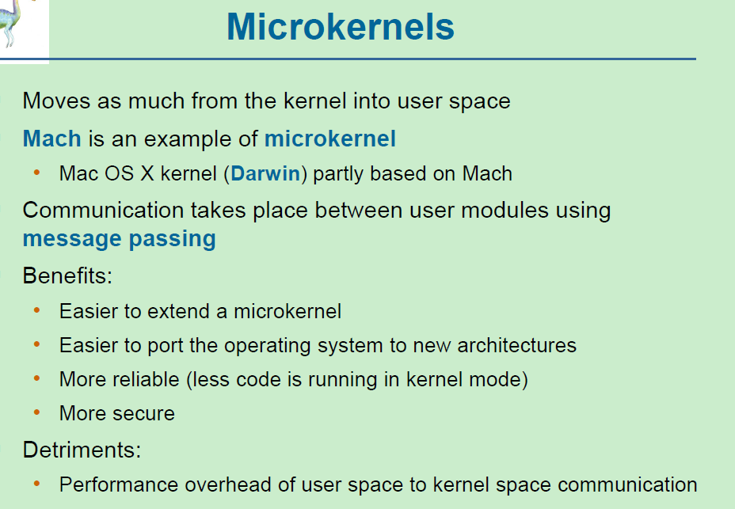
- Why does an operating system design, in general, use layered approach? Please state its advantages and disadvantages. (10%)
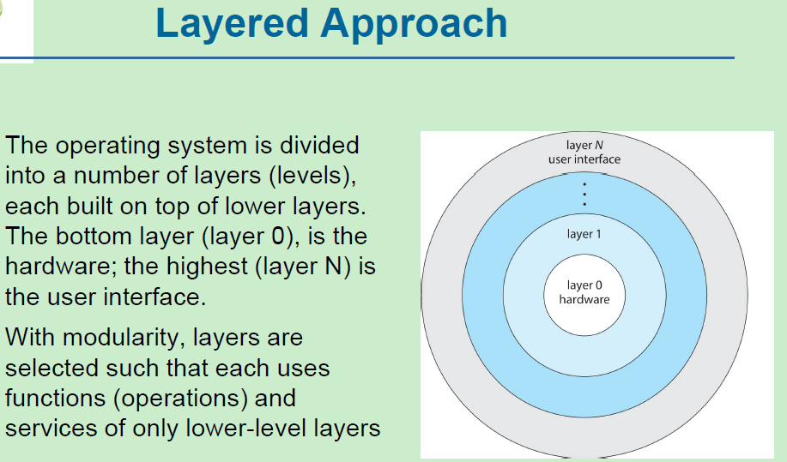
- What is a process? What is a thread? Please compare them. (10%)
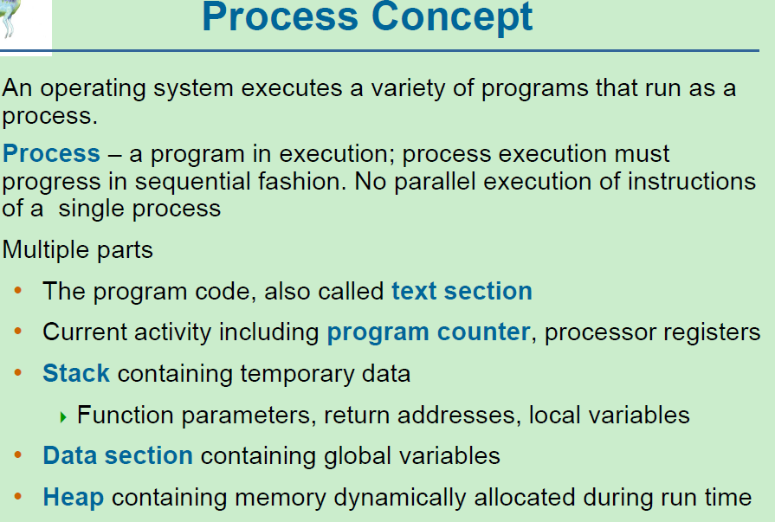
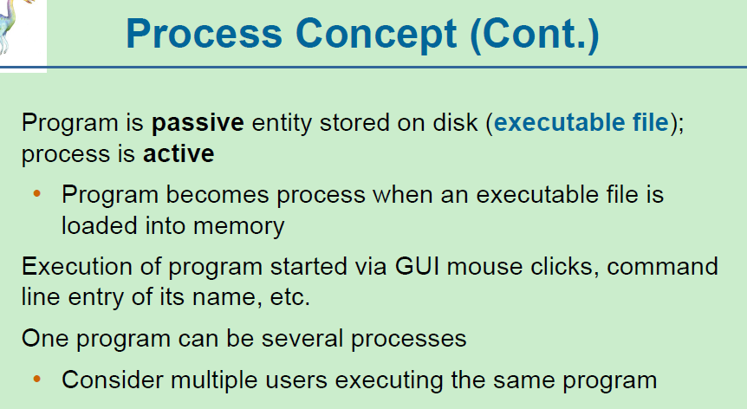
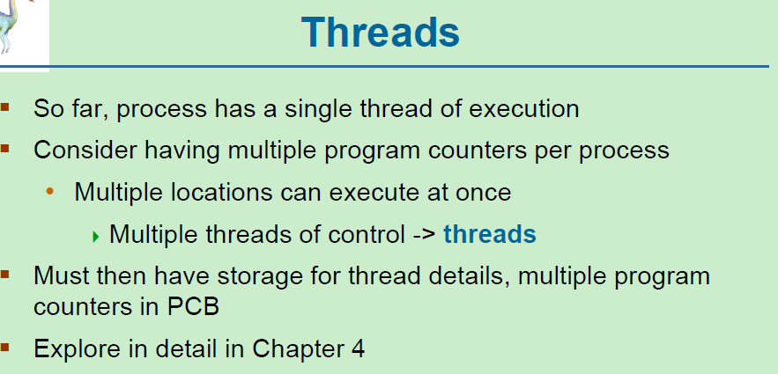
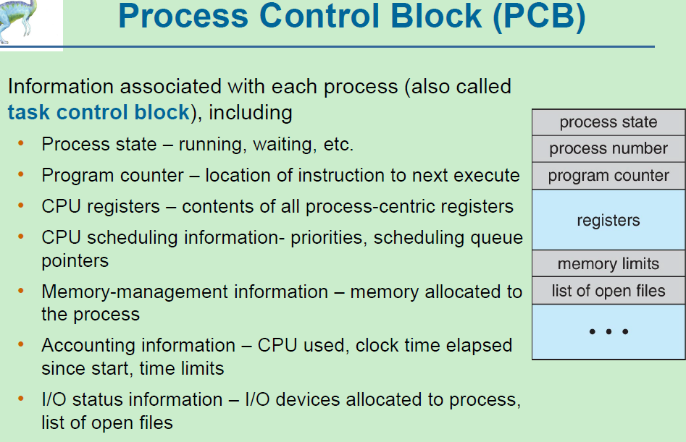
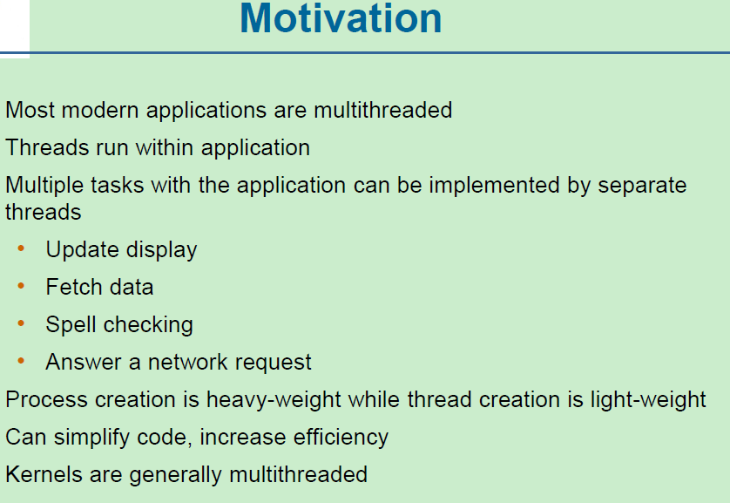
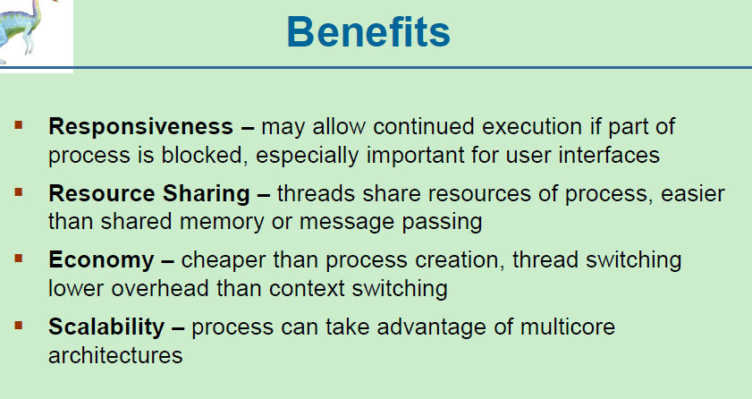
- What resources are used when a thread is created? (10%)
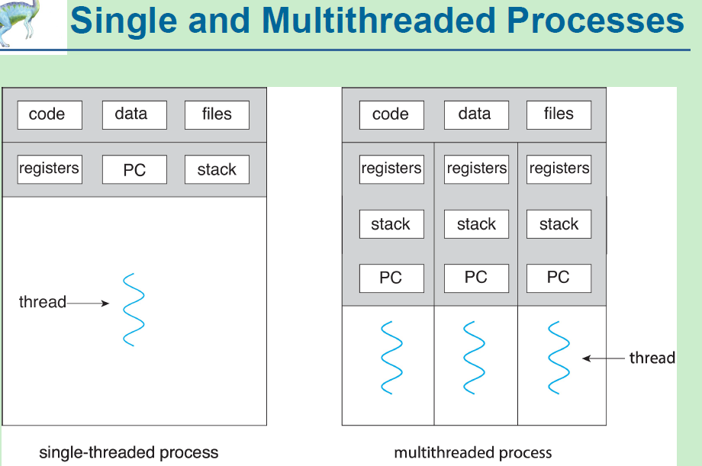
- What are the five states of a process in a computer system? Please describe the relationships of these five process states. (10%)
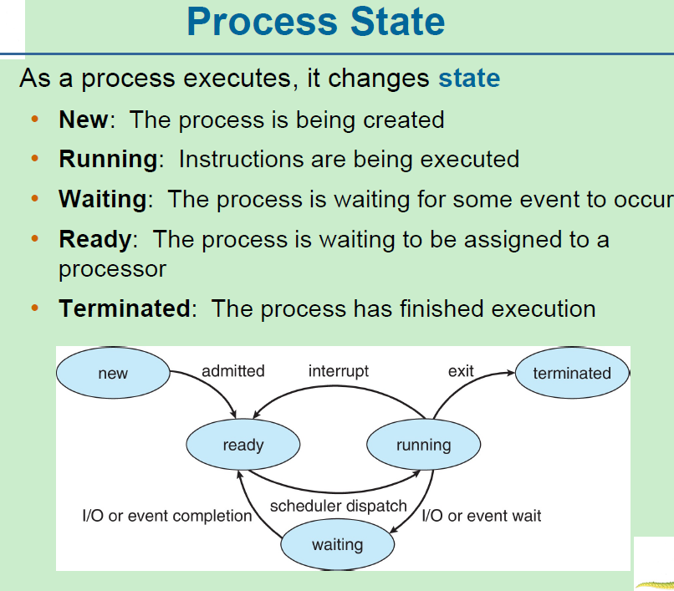
- Describe the actions taken by a kernel to context-switch between processes. (10%)
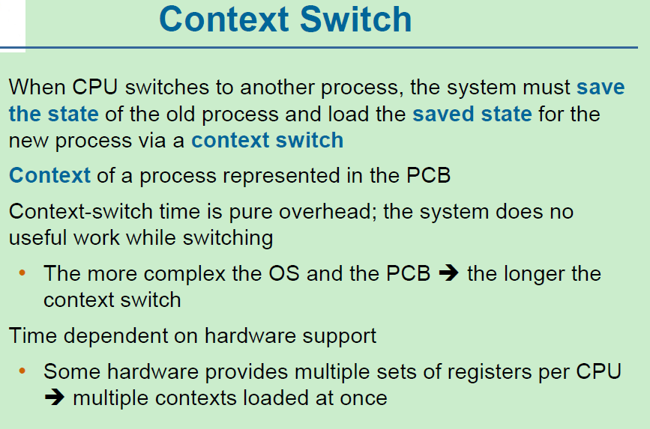
- Why does an operating system have both the user mode and the kernel mode for processes? What are the advantages and disadvantages of the design? (10%)
- Please list and describe three major activities of the operating system with regard to memory management, and three major activities of the operating system with regard to secondary storage management. (10%)
- Can the segmentation and paging mechanisms cooperate with each other? Please give your reasons. (10%)
- What is a Thrashing? How to resolve this problem? (10%)
- What is Table Lookaside Buffer (TLB)? How it works? (10%)
- What are the major purposes of Table Lookaside Buffer (TLB)? How it works if the memory hierarchy includes L1, L2 and L3 caches? (10%)
- What is Interrupt? What are its usages? (10%)
- How to use interrupt and polling mechanisms to do process manipulation? (10%)
- What is the concept of copy-on-write? How does it work? What are the primary advantages of using copy-on-write in operating systems? (10%)
- Why do we need Direct Memory Access (DMA) mechanism? How does DMA mechanism perform data transfer among memory and I/O devices? (10%)
- How to use Memory Mapped I/O mechanism to perform file access operations? (10%)
- Some file systems are good for small file manipulations while others are good for large file operations. How to design a file system that is good for both small and large file manipulations. (10%)
- What are the advantages of the variant of linked allocation that uses a FAT to chain together the blocks of a file? (10%)
- Explain the role of mmap mechanism. What’s the difference between MAP_SHARED and MAP_PRIVATE? When should the mechanism increase and decrease the reference counter of a file? (10%)
- Discuss situations in which the least frequently used (LFU) page replacement algorithm generates fewer page faults than the least recently used (LRU) page-replacement algorithm. Also discuss under what circumstances the opposite holds. (10%)
- Describe the Life Cycle of an I/O request. (10%)
- The 4KB page size for virtual memory has been standard since at least the 1960s. Given the increasing size of modern applications and memory hierarchies, is it time to consider larger page sizes, such as 128KB?
- What are the pros and cons of switching to a larger page size?(6%)
b) What impact would this change have on other parts of the system, such as cache performance, TLB efficiency, and overall memory management? (4%)
- In a file system using the inode structure, a large file exceeding 4GB requires triple indirect entries. Consider a database log file, which is typically very large and continuously appends new logs. The most frequently accessed records are usually the most recent ones, located at the end of the file. Since these records are reached through triple indirection, causing multiple slow disk seeks, what strategies can an operating system employ to speed up access to these frequently accessed records? (10%)
- Implementing a page table can be challenging, especially with large virtual address spaces (e.g., 48-bit virtual addresses). There are three common approaches for implementing a page table: a) Multiple level indexing; b) Hash table; c) Inverted table. For each approach, please discuss their pros and cons. (10%) When discussing, please consider the needed optimizations to make the approach more efficient, and the presence of a decent-sized TLB (Translation Lookaside Buffer).

